|  |  |  |  |
| --- | --- | --- | --- |
| **TITLE** | Grass is not a flower | Positive and Fun | All Things Magical |
| **ARTIST** | Simon Mathewson | Scott Holmes | Thorn & Shout |
| **COMPOSER** | Simon Mathewson | Scott Holmes | Thorn & Shout |
| **COPYRIGHT INFORMATION** | Attribution-NonCommercial-ShareAlike License | Attribution-NonCommercial License | Attribution-NonCommercial-ShareAlike 3.0 United States License |
| **GENRE** | Pop |  |  |
| **SOURCE** | Free Music Archive | Free Music Archive | Free Music Archive |
| **FILE/AUDIO FORMAT** | MP3 Format Sound (.mp3) | MP3 Format Sound (.mp3) | MP3 Format Sound (.mp3) |
| **NUMBER OF CHANNELS** | 2 | 2 | 2 |
| **SAMPLE RATE** | 48000 | 44100 | 44100 |
| **BIT PER SECOND** | 320kbps | 320kbps | 268kbps |
| **BIT RATE** | 320000 | 320000 | 269369 |
| **DURATION** | 00:02:16 | 00:02:59 | 00:03:43 |
| **ALBUM** | Some Silly Songs | Happy Music | Thorn & Shout |
| **YEAR** | 2018 | 2018 | 2012 |

**WEEK 8: METADATA FOR THREE TRACKS**

**Grass is not a flower**

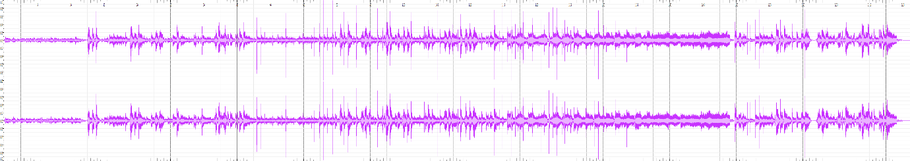**Waveform:**

**Spectogram:**

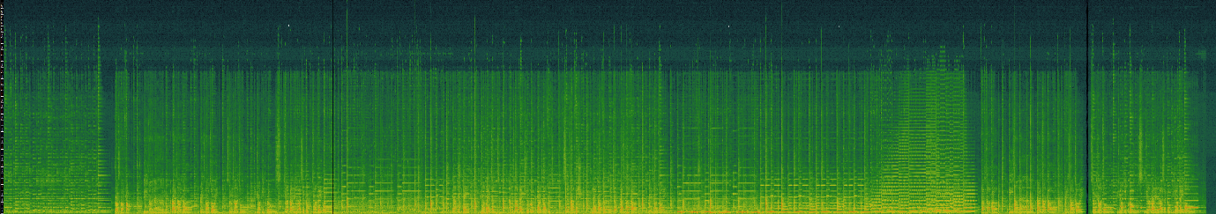

**Positive and Fun**

**Waveform:**

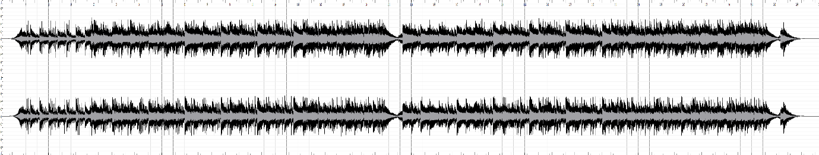

**Spectogram:**

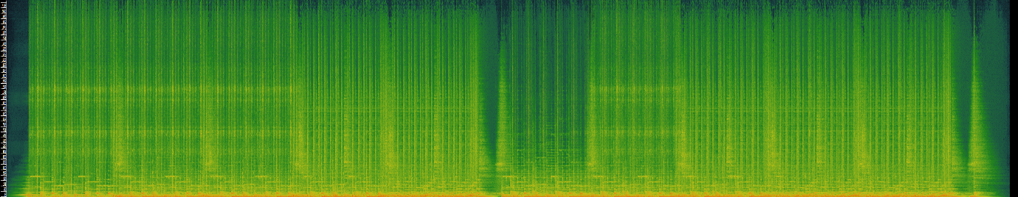

**All Things Magical**

**Waveform:**

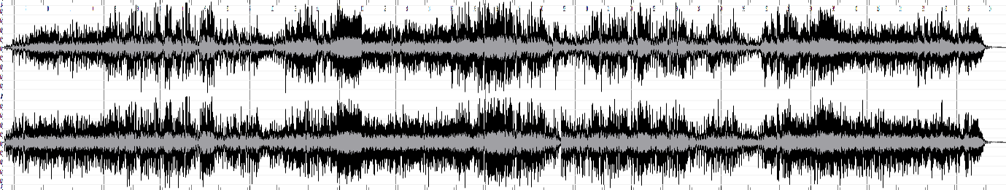

**Spectogram:**

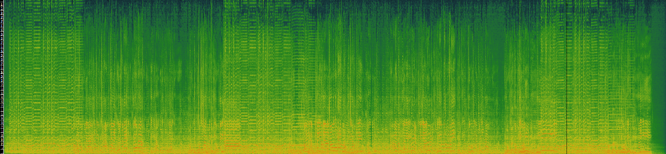

**What are the advantages of Time Frequency over Waveform Analysis?**